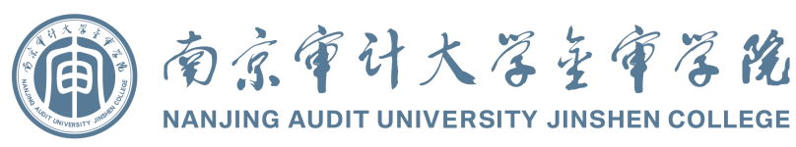**Bachelor’s Degree Certificate**

XXX, male/ female, born on April 18, 2002, has completed the undergraduate program in Auditing at Nanjing Audit University Jinshen College and has graduated. Upon review and confirmation that he meets the requirements of the Law of the People’s Republic of China on Academic Degrees, he/ she is hereby awarded the degree of Bachelor of Management.

President

*Yu Anping*

Chairman of the Academic Degree Evaluation Committee

***Nanjing Audit University Jinshen College***

Certificate No.: 13994xxxxx June xx, 20xx

(Graduate of Regular Higher Education Undergraduate Program)

Regular Higher Education Institution

**Graduation Certificate**

Student XXX, male/ female, born on April 18, 2002, was enrolled in the four-year undergraduate program in Auditing at this College from September 2020 to June 2024. Having completed all courses specified in the teaching plan with passing grades, he/ she is hereby granted graduation.

Institution Name: ***Nanjing Audit University Jinshen College***

President: *Yu Anping*

Certificate No.: 13994xxxxx June xx, 20xx

Academic Certificate Verification Website of the Ministry of Education, P.R.C.: http://www.chsi.com.cn